

Who’s in the Swamp and Upland Forest?
Teacher Resource K-3rd Grade.
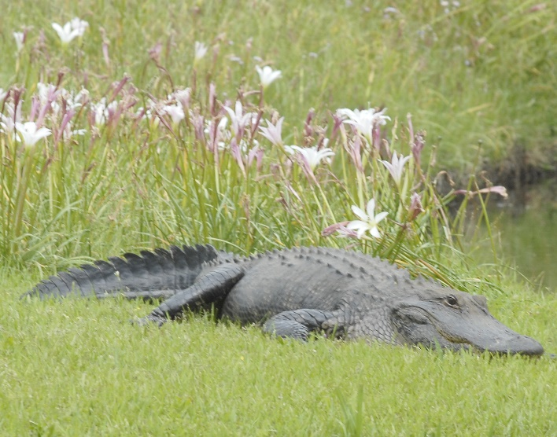
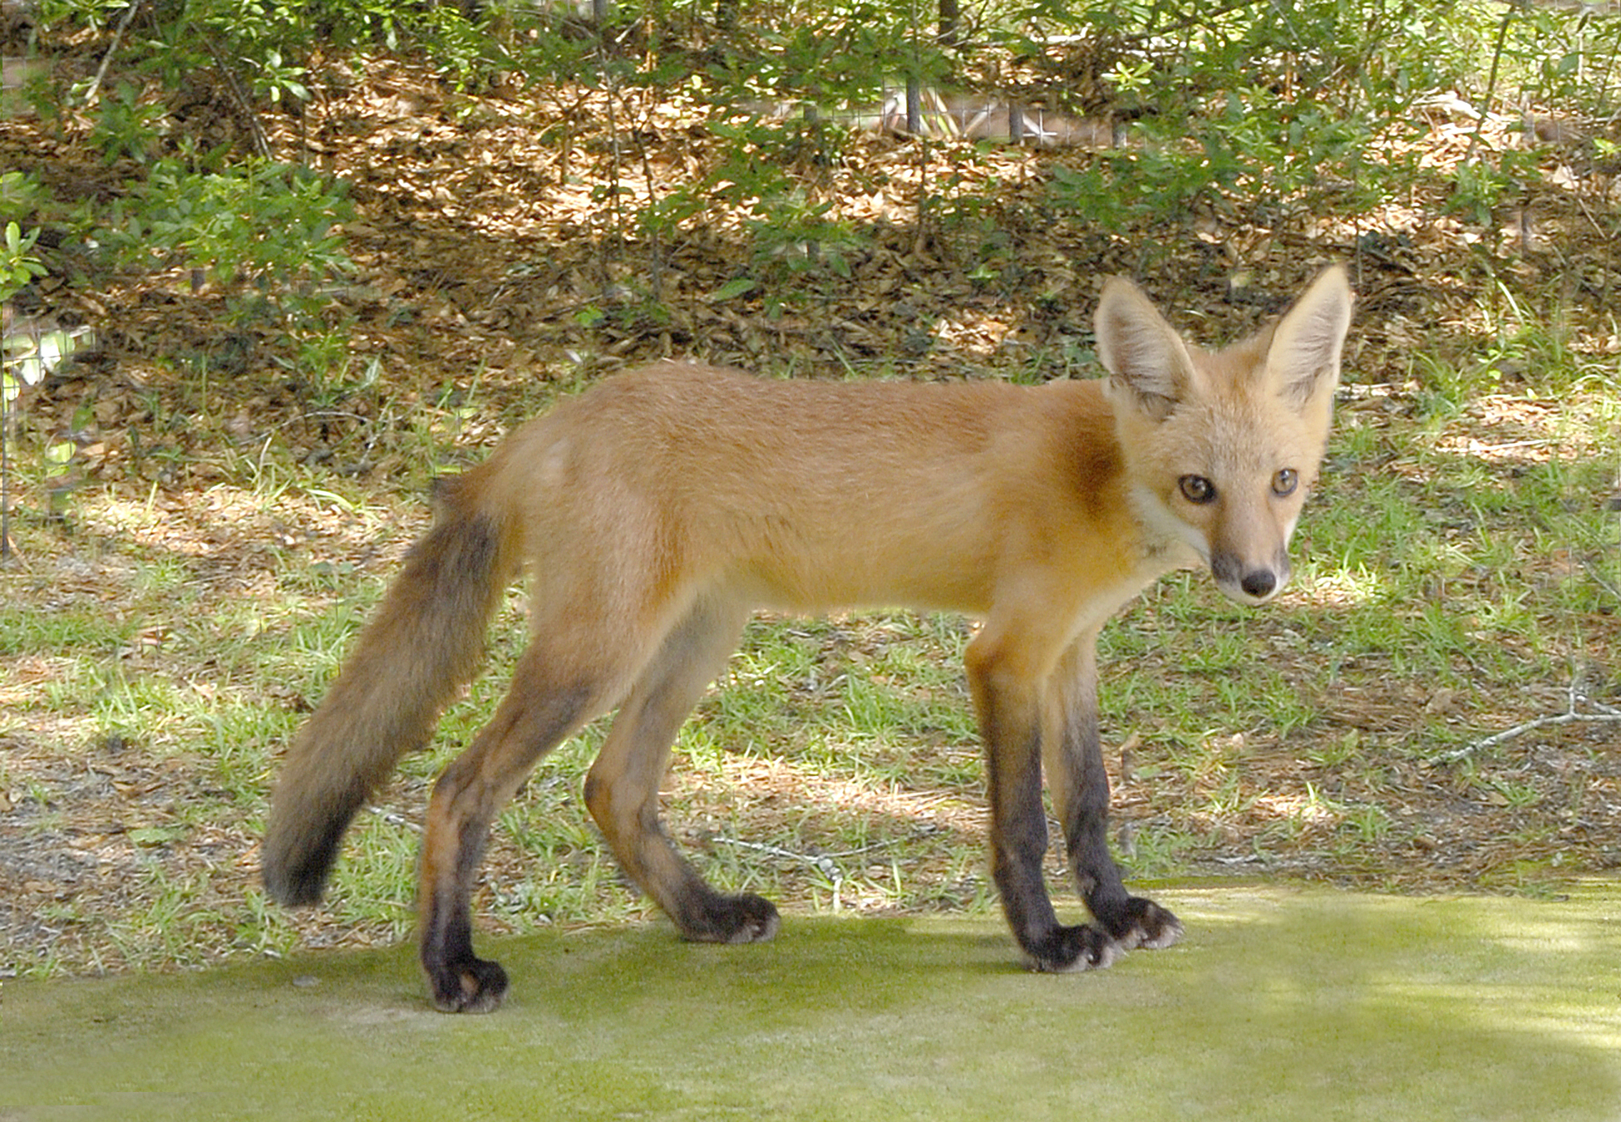
Time to complete: 60 minutes
Content Area: Science, ELA
SC Standard
K-LS1-1. Use observations to describe patterns of what plants and animals (including humans) need to survive.
1-LS1-2. Obtain information from multiple sources to determine patterns in parent and offspring behavior that help offspring survive.
2-LS4-1. Make observations of plants and animals to compare patterns of diversity within different habitats.
3-LS4-2. Use evidence to construct an explanation for how the variations in traits among individuals of the same species may provide advantages in surviving and producing offspring.

Field Trip Tie-In
An excellent accompaniment to this lesson would be a field trip to the Brookgreen Gardens Lowcountry Zoo. There, students will explore animals in both the Swamp and the Upland Forest to uncover characteristics of those animals, learn what they need for survival, and ways they can help preserve these habitats.

Plantation and Native Animals
Students will enjoy a guided tour of our Lowcountry Zoo through two habitats, the Swamp and Upland Forest. Students will discuss the native animals that live there and how their physical features help them survive there.

Objectives:
Students will identify characteristics of swamp and forest habitats.
Students will identify animals that live in the swamp and forest and features that aid in their survival.

Materials:
Forest and Swamp Habitat Pictures (Attached)
Books about Forest and Swamp Habitats and animals from library
Animal Cards (Attached)
Posterboard
Markers or coloring materials
Scissors
Glue
Construction paper
Optional:
Feathers
Yarn
Animal Coloring pages
Paint
Stickers

Vocabulary:
Adaptation: A characteristic or trait that allows an organism to be better suited for survival and
reproduction within a given habitat.
Biodiversity: When many diverse types of animal and plant species live in a particular habitat.
Endangered Species: A species of animal or plant that is in danger of going extinct.
Upland Forest: An area of land that's dominated by trees and undergrowth vegetation.
Fresh Water: Water that does not contain any salt.
Habitat: A place where an animal finds the food, water, and shelter it needs to live.
Pollution: When a harmful substance is out in the wrong place and/or in the wrong quantity and has a harmful effect on the environment.
Survive: To continue to live or exist, especially despite danger or hardship.
Swamp: An area of low-lying, uncultivated ground where water collects. Often considered to be transition zones of both land and water.
Wetland: Land consisting of marshes or swamps; saturated land.

Background:
Some land environments get lots of rain and others get very little. In each environment, animals have habitats where they can find what they need. Swamps are wetlands that have an abundance of shrubs or trees. Swamps are low-lying areas where ground water collects. Wooded swamps provide important habitats for many types of plants and animals.
Animals that live in freshwater swamps have physical features that allow them to build homes, find food, reproduce, and survive in this habitat. Bald Cypress or Tupelo Gum trees that are found throughout South Carolina’s freshwater swamps provide homes for many animals including wading birds, alligators, snakes, and river otters.
Each animal in the swamp plays a key role in their habitat as a predator or prey animal. Freshwater swamps are not only a biodiversity hotspot for animals and plants but considered to be transition zones between land and water. They help purify water and assist with flood and erosion control. (Brookgreen Gardens has tidal swamps with rising and falling water.)
Upland forests are different than swamps and occur where drainage is sufficient so that soil does not become saturated for extended periods of time. Water can either run off or absorb through the soil. Upland forests are dynamic environments that are home to many plants and animals. Pine trees can create a nice tree canopy which blocks light from reaching the forest floor. Each layer of the forest has a diverse animal and plant population including raptors, foxes, deer, and wolves. These animals are adapted to live on dry land with a diversity of plants.

Procedures:
1. Introduce the lesson by asking students to think about what kinds of things animals need to survive. Write “What animals need” on the whiteboard. Write their answers. At the end circle food, water, shelter, air, and a place to raise their young.
2. Ask students “What is a habitat?” Place the pictures of the swamp and forest on the whiteboard. Explain to students that animals make their homes where their needs can be met.
3.Describe to students the two different habitats.
Swamp- wet, low-lying, contains Cypress trees and/or Tupelo Gum trees, ground water collects and helps prevent flooding, varying water levels and is home to diverse animals.
Upland Forest-high and dry, diverse trees including pines and oaks, different layers of diverse plants.
4. Show a picture of the pine tree and bald cypress tree and ask students to share which tree can survive in which habitat and why. Place the Cypress Tree image next to the Swamp image and point out the trees’ knees. This is the tree’s root system. Show the Longleaf Pine tree and place it with the forest image.
5. Distribute animal cards.
6. Ask students to look at their cards and decide which habitat the animal can survive in. (Some animals can live in both.) Explain that animals are adapted to live in their habitat.

Swamp Example: Wading birds have long legs to stand in the waters of the swamp. River otters and alligators have webbed feet to help them swim in freshwater swamps and prefer to live in a dual habitat (land and water). An alligator’s nostrils and eyes are on top of its head so that it can camouflage under water as it hunts its prey. Bald eagles nest high in the trees to protect their young from predators.

Forest Example: Owls nest in the cavities (hole) of trees. Grey Foxes live in the forest and sleep in trees during the day to camouflage from predators. Red Cockaded Woodpeckers only nest in 90+ year old Long Leaf Pines and are now endangered. If their needs are not met, animals will adapt, relocate, or become endangered. (The Red Cockaded Woodpecker is endangered due to its nesting habitats in only aged Long Leaf Pine trees.)
7. Place a poster board with the words Swamp and Forest in the room. Ask students to sort their animals by their habitats.
8. Ask students to share their animal and why they think it would live there. Make corrections or clarifications as needed for student responses.
9. Break students up into groups of 4-6 and give each group “swamp” or “forest”.
10. Pass out books from the library for students to use to learn more about the forest and swamp habitat and the plants and animals that live there.
11. Pass out a sheet of white paper to each student, coloring materials, and scissors.
12. Have each student draw and cut out an animal that would live in the habitat they were given.
13. Pass out posterboard to each group and materials to create a mural. Have students create a mural of the forest or swamp and add their hand-drawn animals or coloring pages to the mural.
14. Ask students to share what they think would happen to the animals if there needs were no longer met in these habitats. (Relocation or become endangered)
15. Have students share their habitat mural with the class.

Assessment:
Examine murals to see if the students were able to identify the correct characteristics of their given habitat and include animals that live there. Give assistance in completing the project where needed to ensure understanding.

Extension Activity:
After your field trip to Brookgreen Gardens, small groups gather back together to add more animals, plants, and details to their murals.

Additional Resources:
Learn more about swamps at:
https://education.nationalgeographic.org/resource/swamp/
https://www.britannica.com/science/swamp
Learn more about forest:
https://kids.nationalgeographic.com/nature/habitats/article/temperate-forest
https://www.britannica.com/place/South-Carolina/Plant-and-animal-life

Great Read Alouds:
Crinkleroot's Guide to Knowing Animal Habitats by Jim Arnosky.
Swamp Life by Theresa Greenaway.
National Geographic Readers: In the Forest by Shira Evans.

