Whispering Wings of Pollinators

Teacher Resource Grade Level 2-4

**Time to complete:** 50 minutes

**Content Area:** Science

**SC Standards:**

**Standard 2.L.5:** The student will demonstrate an understanding how the structures of animals help them survive and grow in their environments.

**Standard 3.L.5:** The student will demonstrate an understanding of how the characteristics and changes in environments and habitats affect the diversity of organisms.

**Standard 4.L.5:** The student will demonstrate an understanding of how the structural characteristics and traits of plants

and animals allow them to survive, grow, and reproduce.

**Field Trip Tie In**

An excellent tie-in to this lesson would be a field trip to Brookgreen Gardens to observe pollinator in action.

**Whispering Wings**

Students will learn fun and interesting facts about butterflies, their lifecycle, and defenses. After an introductory lesson, students will explore the butterfly exhibit to observe these pollinators at work.

**Bee Educated**

Students will get the buzz about bees through an interactive presentation with manipulatives, real bees, and fun. Students will observe an active observation hive and learn about the importance of honeybees and other pollinators.

**Materials:**

Different flowers (or pictures)

Pollinator Cards (2 or more sets printed out)

4 Flower Print outs

Pom pom balls

2 spoons

Large Paper or Poster board

Markers or crayons

**Objectives:**

Students will be able to identify at least two types of insect pollinators.

Students will learn about pollinators and their relationship to flowers.

**Vocabulary:**

**Pollination-** the transfer of pollen to a stigma, ovule, flower, or plant to allow fertilization.

**Pollinators**- A pollinator is an animal that helps plants produce fruit or seeds.

**Insect-** Insects are characterized by three-part bodies, usually two pairs of wings, and three pairs of legs, and two antennae.

**Cell**- a single cell is a small part of the structure on which bees live their lives.

**Nectar-** a sugary fluid produced by plants, especially within flowers to encourage pollination by insects and other animals.

**Background:** Pollination is a vital stage in the life cycle of flowering plants. It occurs when pollen is moved between two flowers of the same plant species. Pollination may occur by wind, water, or animals. Pollinators are animals such as butterflies, bees, beetles, and birds. Insects are important pollinators that are attracted to a plant’s bright colors, smell, and even shape of a flower. As insects, like bees and butterflies, drink the nectar of different flowers, they carry pollen from flower to flower, which enables plants to produce fruits and seeds. These seeds, in turn, allow for new generations of the plants to grow.

More than 100 U.S. grown crops rely on pollinators. Humans and animals depend on these plants for survival. Many fruit, vegetable, and seed crops are pollinated by animals.

Pollinators face many challenges such as habitat loss, pesticide exposure, competition with non-native species, parasites, and climate change. There are many things we can do to help pollinators! Adding native, pollinator friendly plants to the landscape to provide pollen and nectar, reducing the use of pesticides and increased conservation practices will help support pollinator survival.A butterfly on a flower

**Procedures:**

1. Show students a group of flowers you have collected or pictures of different flowers. (Flowers should be different shapes and colors.)

2. Have students vote on their favorite flower and share in small groups why that was their favorite flower (color, smell, shape).

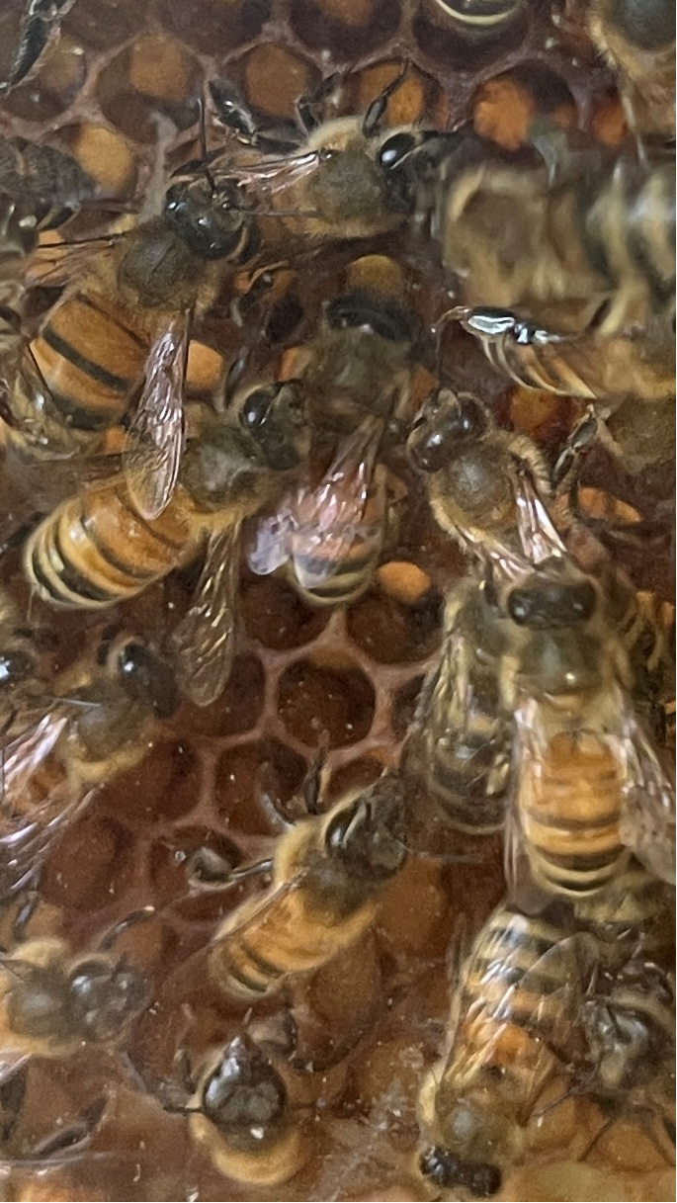3. Tally up their votes to see which flower the students liked best.

4. Explain to students that just like how they prefer some flowers over others, so do pollinators.

5. Explain to students that pollinators can be bees, butterflies, beetles, birds, or even bats.

6. Show the picture of the Painted Lady Butterfly and discuss common features of butterflies with students. (Three sections, four wings, six legs, and a proboscis that acts as straw). Ask students to describe or draw butterflies they have seen. Explain that butterflies use their proboscis to drink nectar from preferably tube-shaped flowers. When a butterfly lands on a flower to drink nectar, the flower's pollen becomes attached and as the butterfly moves from flower to flower drinking more nectar, the pollen is transferred.

7. Show a picture of the honeybee. Share information about the honeybee and its love of lavender, clover, and mint (can have plants for children to observe). Inform students that bees use pollen and nectar as food. Nectar provides them with carbohydrates, and pollen is their source of protein and fat. Honeybees stuff pollen into baskets on their legs and use their tongues (proboscis) to suck up nectar. They take the nectar back to the hive where they are put into cells. There, these ingredients will be processed into honey and a substance called “bee bread” which they feed to their young.

8. Students will do a “spoon and egg” like relay to move pollen from one flower to another. Create a starting line and divide the class into two “hives” or groups.

9. Each group is to pick up a pollen grain and move the pollen from the starting flower to the other flower at the finish line. The first group to get all their pollen grains from one flower to the other wins.

10. Next, pass out the Pollinator Cards to the class. Multiple students should have the same card.

11. Ask students to find students with the same pollinator cards and discuss their pollinator and the facts provided.

12. Next, students should create a Pollinator Poster to share information with the class (individual or small group).

13. Have small groups/partners share information about their pollinator to the class. (You can provide books from the library if you want them to learn more than the facts provided.)

Books:

Flight of the Honey Bee by Raymond Huber

Butterflies by Marfe Ferguson Delano

Are You A Butterfly? by Judy Allen

The Life and Times of the Honeybee by Charles Micucci

**Assessment:**

Exit Slip

**Exit Slip**

Name:________________________

What is a pollinator?

___________________________________

___________________________________

___________________________________

Name 2 pollinators:

1. __________________________________

2. __________________________________

Why are pollinators important?

____________________________________________________________________________________________________________